APPLECROSS SENIOR HIGH SCHOOL

Total: _______/55

Year 12 Human Biology 2015 / 2016

Test 1: Immune Response

**PART A: Multiple Choice Section [Total: 20 marks]**

1. Antibiotics are often ineffective against viruses because viruses

(a) keep changing their external protein coat.

(b) are able to disguise themselves in the host cell membrane.

(c) are not true living cells, so their metabolism is not affected by antibiotics.

(d) can destroy or inhibit the actions of antibiotics in living cells.

2. The advantage of a naturally acquired, active immunity is that it

(a) is long lasting, sometimes for life.

(b) can develop without exposure to antigen.

(c) produces antibodies against a range of infective agents.

(d) provides antibodies immediately the first time one is exposed to a particular bacterium.

3. Macrophages are large white blood cells that

(a) divide to produce B lymphocytes.

(b) engulf bacteria and destroy them.

(c) produce antibodies against specific antigens.

(d) secrete bacterial-destroying enzymes into the blood.

4. Which of the following is an example of passive natural immunity?

(a) The body manufactures antibodies in response to an invading pathogen.

(b) Antibodies enter the blood stream via an injection of antitoxin.

(c) The body manufactures antibodies after an injection of toxoids.

(d) Antibodies enter the blood stream from mother to foetus across the placenta.

5. Which of the following differentiates correctly between antibiotics and vaccines?

(a) Antibiotics treat for an invading bacterium, while many vaccines involve the introduction of an inactivated pathogen into the bloodstream.

(b) Antibiotics provide long-lasting immunity due to the production of memory cells, while vaccines only provide short-term immunity.

(c) Antibiotics provide artificial, active immunity, while vaccines provide artificial, passive immunity.

(d) Antibiotics are often injected into the bloodstream, while vaccines are normally ingested in pill form.

6. Which of the following statements best describes what is most likely to happen when an individual receives a vaccination containing a weakened pathogen? The ability to

(a) fight the disease caused by the pathogen will increase due to antibody production.

(b) fight the disease will increase due to antibodies received from the pathogen.

(c) produce antibodies will decrease after vaccination.

(d) resist most types of diseases will increase.

7. Micro-organisms that cause disease in other living organisms are known as

(a) decomposers.

(b) antigens.

(c) antibiotics.

(d) pathogens.

8. A virus is injected into an animal and the animal is then left to fight the infection by making antibodies to the virus. The antibodies can then be removed from the animal and injected into a human who is infected with the same virus. This is an example of

(a) natural immunity.

(b) innate immunity.

(c) passive immunisation.

(d) active immunisation.

9. One important response to an infection is the antigen-antibody reaction. Which of the following is NOT a feature of such a reaction?

(a) The antibody is specific for a particular antigen.

(b) Antibodies are found in blood plasma and are all proteins.

(c) The range of antibodies possessed by an individual is inherited and has been present since birth.

(d) Antibodies are associated with phagocytes in protecting the body.

10. A typical characteristic of a virus is that it

(a) is destroyed by antibiotics.

(b) releases toxins into the body of the host.

(c) evades detection by the host's immune system.

(d) manipulates the host cell's DNA to produce copies of itself.

11. The table lists the types of microbes identified in a cheeseburger prepared at an outdoor market.

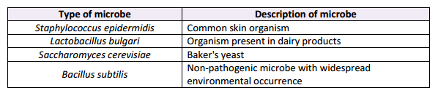

Would it be safe to eat this cheeseburger?

Choose the best answer from the following.

(a) No, food should be completely free of microbes

(b) No, Lactobacillus and Saccharomyces are highly pathogenic

(c) Yes, organisms that grow in or on the human body do not cause disease

(d) Yes, most of the food we eat is contaminated by different microbes

12. An example of specific immunity is the

(a) action of mucus to remove bacteria from the respiratory tract.

(b) presence of 'natural flora’ bacteria in different areas of the body.

(c) presence of antibacterial agents, such as enzymes, in saliva.

(d) action of memory cells when an individual is subjected to a second infection of measles.

13. After contact with the polio virus, a child developed polio and recovered. Twelve months later, the child came in contact with the polio virus again but did not show any symptoms of the disease. This happened because, shortly after the first infection, the child

(a) had an injection of polio antibodies.

(b) grew memory B cells specific to polio.

(c) grew memory B cells that could respond to any virus.

(d) developed T cells that consumed the new polio virus particles.

14. Penicillin is an example of an

(a) antibiotic.

(b) antibody.

(c) antigen.

(d) antitoxin.

15. The following diagrams show the antigens on the surface of different bacteria isolated from an open wound.



Antigen 1 Antigen 2 Antigen 3 Antigen 4

An antibody was also detected. It is shown below.

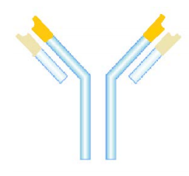

This antibody is most likely to react to antigen

(a) 1.

(b) 2.

(c) 3.

(d) 4.

16. Of the different types of Leucocytes, which are involved in the formation of T-cells and B-cells?

(a) monocytes.

(b) basophils.

(c) eosiophils.

(d) lymphocytes.

17. Ig is the abbreviation for Immunoglobulins. One Ig usually contains two pairs of polypeptide chains. The ends of these chains are referred to as ‘variable portions’. What is the common name for Immunoglobulins?

(a) antibodies.

(b) cytotoxins.

(c) macrophages.

(d) antigens.

18. Which of the following is the hallmark of the humoral immune response?

(a) phagocytosis.

(b) binding of antibodies to antigens.

(c) cell lysis by T-cells.

(d) antigen presentation.

19. Antigens

(a) are produced by lymphoctyes.

(b) are hormones produced by the endocrine glands.

(c) are foreign substances such as bacteria and viruses.

(d) have phagocytic abilities.

20. Inflammation in the area of a wound, like a tear in the skin, is a useful reaction to the damage because:

1. It results in more blood flow to the area.
2. It allows more seepage of plasma from the capillaries into the surrounding tissue.
3. It may enable a blood clot to form more readily in the area.
4. All of the above.

**PART B: Short Answer Section [Total 23 marks]**

21. Describe **four** of the body’s external defences against infection by bacteria.

**Skin:** forms an impervious barrier (1) **sebum** is secreted by oil glands and kills some bacteria (1), sweat secreted onto the skin contains salts and fatty acids that prevent the growth of many micro-organisms (1)

**Ears:** **cerumen** is slightly acidic and contains **lysozymes** with kill bacteria (1)

**Eyes:** cleansed by tears / flushing action keep them free of pathogens (1) tears contain the enzyme **lysozyme** which kill bacteria (1)

**Respiratory Tract:** Trachea and bronchi have a mucus layer that traps micro-organisms (1), **cilia**  is the trachea and nasal passage move the mucus towards the throat where it can be swallowed or coughed up (1), hairs found in the nose trap particles inhaled when breathing (1)

**Urogenital System:**  acidic secretions in the vagina inhibit the growth of pathogens (1), flushing action in the urethra stops bacteria reaching the bladder and kidneys (1), mucus membrane prevent the entry of micro-organisms into the organs of the body (1)

**Digestive System:** stomach acid kills many bacteria ingested with food (1), mucus membrane prevent the entry of micro-organisms into the organs of the body (1)

**ANY 4 POINTS**

22. The diagram below shows one of the actions of antibodies on pathogens.

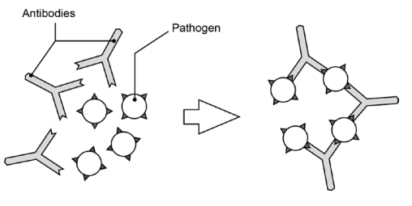

1. What action of antibodies does the diagram represent? (1 mark)

Agglutination / clumping together of pathogens

1. Describe **three** other ways in which antibodies can act on pathogens to help fight infection. (3 marks)

• Neutralise them / inactivate them / combine with foreign enzymes or bacterial toxins, or inactivate them by inhibiting reaction with other cells or compounds

• Bind to surfaces of viruses, preventing them from entering the cell

• Make soluble substance insoluble / form a precipitate

• Coat bacteria so they are more easily consumed by phagocytes / enhance phagocytosis / make them more easily consumed

• Dissolve organisms

23. The effects of many diseases have been minimised in many countries due to the introduction of live attenuated vaccines. A live attenuated vaccine uses a weakened version of the disease-causing pathogen to stimulate an immune response in the vaccinated person. The MMR (measles, mumps and rubella) vaccination program attracts a lot of media attention, which highlights some of the risks and ethical considerations associated with the use of vaccines.

Discuss **two** benefits and **one** risk for the use of vaccines. (3 marks)

Benefits: **Any 2 points**

• Causes an immune response to develop long-term immunity

• Stops the individual from contracting the disease

• Herd immunity – if enough people are vaccinated, it could stop the pathogen affecting the whole community

• Generally only requires a single dose for immunity to develop

• Fewer side effects than active natural immunity

Risks: **Any single point**

**•** Possible mild allergic reaction to the vaccine

• Possible reversion of pathogen to more virulent form may make vaccine ineffective

• Can’t be given to immune-compromised patients

24. Parts (a) – (c) of the questions refer to the graph below, which shows the trend in antibody levels in the blood after first and second exposure to an antigen.

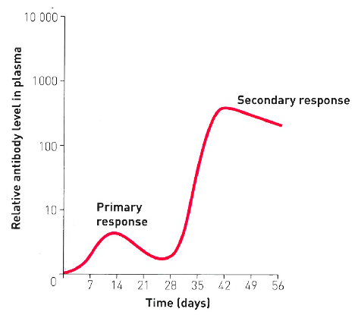

1. Using the information from the graph, describe **two (2)** differences between the responses to the first and second exposures. **Any 2** (2 marks)

• Response after 1st exposure takes longer to occur / antibodies don’t appear immediately after the 1st exposure

• 2nd exposure peaks at a higher level / more antibodies are produced after the 2nd exposure / due to memory cells

• levels of antibodies are maintained longer after the 2nd exposure

1. Describe how the antigen causes a change in antibody levels following the first exposure. **Any 4 points** (4 marks)

• Antigens are engulfed by macrophages

• Antigens are presented to B cells/ lymphocytes

• B cells are sensitised

• B cells enlarge

• B cells clone

• B cells form plasma cells

• Plasma cells produce antibodies

• Antibodies are then released into the blood stream

1. What cell type is present at the beginning of the second exposure but not at the beginning of the first exposure? (1 mark)

Memory cells

25. Inflammation and fever are both considered the body’s second line of defence.

1. State the role of histamine in inflammation: (2 marks)

**Any 2 points**

Histamine increases blood flow through the area (1) and causes the walls of the blood capillaries to become more permeable (1), so that fluid is filtered from the blood (1).

1. Name the cell that secretes histamine: (1 mark)

Mast cells / basophils

1. How is fever during the course of an infection thought to be beneficial?

(2 marks)

**Any 2 points**

The beneficial effects of fever result from the elevated body temperature that inhibits the growth (1) of some bacteria and viruses (1).

In addition, heat increases the rate of chemical reactions (1), which may assist body cells to repair themselves more quickly during an infection (1).

**PART C: Extended Response [Total 12 marks]**

You must answer both parts (a) and (b) of question 25. If you use a page of planning, please use the pages at the end of the booklet and clearly indicate at the top of the page that it is your plan.

25.

(a) Construct a table showing the differences between Natural and Artificial Immunity. Include in your answer:

1. The different categories of each type
2. How they are obtained
3. How it provides immunity

Poorly constructed tables will incur a penalty (max – 2 marks)

(6 marks)

|  |  |  |
| --- | --- | --- |
|  | Natural | Artificial |
| I: Different categories | Passive an active **(1/2 mark)** | Passive and active **(1/2 mark)** |
| II: How they are obtained | No intervention is required **(1/2 mark)**  Natural Passive: Antibodies are received from mother to baby from breast milk (colostrum) or via placenta during pregnancy **(1/2 mark)**  Natural Active: Own body manufactures antibodies from an attack of the disease **(1/2 mark)** | Obtained via an injection **(1/2 mark)**  Artificial passive has injection on antibodies **(1/2 mark)**  Artificial active has an injection of an antigen (vaccine) **(1/2 mark)** |
| III: How it provides immunity | Natural passive: antibodies received from the mother can react with antigens. Short-term immunity due to the absence of memory cells. **(1/2 mark)**  Natural active: Antigen is contracted naturally and the body’s immune system recognises antigen and produces its own antibodies as a response. Long-term immunity due to the production of memory cells. **(1/2 mark)** | Artificial passive: injected antibodies react with antigens in the bloodstream. Short-term immunity due to the absence of memory cells. **(1/2 mark)**  Artificial active: injected antigen is recognised by the immune system and the body produces its own antibodies as a response. Long-term immunity due to the production of memory cells. **(1/2 mark)** |

Table must have heading and a logical structure (may vary from the example above)

(b) A female with a defective kidney received a new kidney transplant from a non-related male. The female patient failed to take the appropriate medication and the transplant was rejected. Describe the cell-mediated immune response that resulted in the rejection of the transplanted kidney. (6 marks)

**Max 2 marks – recognising non-self**

• Lymphocytes have antigen receptors on their surface

• Our own cells are marked with MHC proteins / antigens that allow the body to recognise it as self

• MHC = major histocompatibility complex

• Foreign kidney tissue would have different MHC proteins on its surface and would be recognised as non-self

**Max 4 marks – cell mediated response**

• Macrophages will engulf non-self cells and present the non-self antigen on its surface

• Helper T cells recognise non-self antigen

• Helper T cells release cytokines (chemical messengers)

• T cells to clone / undergo mitosis

• Cytotoxic T cells / killer T cells are produced

• Helper T cells attract macrophages / stimulate phagocytosis

• Helper T cells promote the action of cytotoxic / killer T cells

• Cytotoxic / killer T cells destroy the foreign tissue (by secreting chemicals)

• Suppressor T cells inhibit / slow down immune response when completed

• Memory T cells are produced and remain, provide faster / stronger response in future.